

A Project Report

On

**“MediMate -Making HealthCare Support Easy,One Chat AT A Time”**

Batch Details

|  |  |  |
| --- | --- | --- |
| Sl. No. | Roll Number | Student Name |
| 1 | 20211IST0014 | Shruti Kumari |
| 2 | 20211IST0002 | M K Sugunashree |
| 3 | 20211IST0003 | Huzaifa Shariff |
| 4 | 20211IST0013 | Tamanpreet Kaur |

**School of Computer Science,**

**Presidency University, Bengaluru.**

Under the guidance of,

**Ms. Monisha Gupta**

School of Computer Science,

Presidency University, Bengaluru

**CONTENTS**

1. Introduction
2. Literature Review
3. Objectives

## Experimental Details/Methodology

1. Design Procedure
2. Expected Outcomes
3. Timeline of the project
4. Conclusion
5. References
6. **INTRODUCTION**

In the information age, customer support has become a crucial tool for companies to communicate with customers. Artificial intelligence (AI) has improved digital marketing in various sectors, but it underestimates the complexity of human language. Companies use chatbots and natural language processing (NLP) to assist customers through desktop interfaces. These technologies can aid human-machine communication, such as machine translation and conversational agents. AI and NLP have emerged as new fronts in IT customer service chatbots, especially when technicians are unavailable due to work hours or absences. This project aims to develop an automated chatbot using deep learning to provide customers with the right information and response from a trusted source at the right time.

Customer support is crucial for companies to provide before and after-sale services, and virtual agents (Chatbots) are used to provide assistance through desktop interfaces. This research focuses on creating an interactive AI agent using natural language processing and deep learning techniques like Long Short-Term Memory, Gated Recurrent Units, and Convolution Neural Network to automatically generate a chat between a computer and a human. Sequence-to-sequence learning is applied, and computational techniques for learning, understanding, and producing human language content are needed. Data preparation efforts are discussed, followed by model design, response generation, and evaluation metrics like Bilingual Evaluation Understudy and cosine similarity. Experimental results show promising results, particularly with Long Short-Term Memory and Gated Recurrent Units, which are useful for emotional queries and general, meaningful responses. LSTM is chosen as the final model due to its best results in all evaluation metrics.

1. **LITERATURE REVIEW**

Chatbots that adopt a [machine learning approach](https://www.sciencedirect.com/topics/computer-science/machine-learning-approach) have been used in many different industries and applications, such as education ([Kerlyl et al., 2006](https://www.sciencedirect.com/science/article/pii/S1567422321000703?ref=pdf_download&fr=RR-2&rr=8d5d9fa519cb7ea3" \l "b0135)), medical ([Laranjo et al., 2018](https://www.sciencedirect.com/science/article/pii/S1567422321000703?ref=pdf_download&fr=RR-2&rr=8d5d9fa519cb7ea3" \l "b0155)), and government ([Androutsopoulou et al., 2019](https://www.sciencedirect.com/science/article/pii/S1567422321000703?ref=pdf_download&fr=RR-2&rr=8d5d9fa519cb7ea3" \l "b0015)). Chatbots are frequently used to facilitate customer service experience, including but not limited to selling, promotion and customer engagement. ([Androutsopoulou et al., 2019](https://www.sciencedirect.com/science/article/pii/S1567422321000703?ref=pdf_download&fr=RR-2&rr=8d5d9fa519cb7ea3" \l "b0015), [Cui et al., 2017](https://www.sciencedirect.com/science/article/pii/S1567422321000703?ref=pdf_download&fr=RR-2&rr=8d5d9fa519cb7ea3" \l "b0080)).

All the studies aim at presenting the chatbot design or architecture that addresses the identified research problems, gaps, or questions. The chatbots serve customers in different industry sectors, including tourism (Acharya et al., 2020), e-commerce (Bhawiyuga et al., 2017), and telecommunication (Paikens et al., 2020). The motivations of the studies usually come from the limited research on the desired chatbots (Bhawiyuga et al., 2017; Luo and Tong, 2019; Paikens et al., 2020; Wang et al., 2019; Schanke et al., 2021) or the existing approaches that cannot do well at some specific situation or address some specific problems (Chakrabarti and Luger, 2012; Chakrabarti and Luger, 2015).

In most of the studies, system prototypes were developed (Acharya et al., 2020; Chakrabarti and Luger, 2015; Paikens et al., 2020), some of which were evaluated through user survey, expert review, or experiments. Almost all the evaluation results for the system prototypes reported that the proposed chatbots performed well and effectively. They could improve the performance, accuracy, or efficiency of the operations.

The chatbots could improve the end-to-end user experience because it is more convenient for customers to acquire information during online shopping (Cui et al., 2017), thereby helping save time and human effort (Paikens et al., 2020). Some studies present the conceptual design without developing a prototype or conducting any evaluation, such as (Kurachi et al. 2018).

A KB contains the required knowledge and information to support artificial conversation, such as product information, frequently asked questions (FAQs), dialog history, historical behaviors, and facts. The conversational agents will retrieve the required information or knowledge from the KB to understand customers’ queries and construct answers to the questions.

From the literature, a number of chatbots are supported by KB containing FAQs and data crawled from external sources, such as webpages (Herrera et al. 2019).There are also some chatbots that answer queries incorporating chat history (Griol and Molina 2016; Wang et al. 2019) or user profiles and behaviors (Cha et al. 2019).

Researchers found that the chatbot with a KB and dialog history can generate more informative responses (Wang et al. 2019).However, all of them only discuss the KB briefly, without any deeper investigation into it. Moreover, the designs of the KBs in those studies are not underpinned by any theoretical basis. On the other hand, to maintain the quality of the information and knowledge supporting effective conversations between the conversational agent and customers, the KB must be updated. However, based on the literature of KB-supported chatbot, this issue was overlooked.

Text-based chatbots are used in various financial sectors, such as banking, insurance and ecommerce services, to improve the existing quality of customer service, user satisfaction, human productivity and workload, etc. Suhel et al. (2020) revealed that implementing chatbots in banking and financial sectors can increase the quality of user service, productivity and proportion of satisfied users, as well as reduce human workload.

Illescas-Manzano et al. (2021) reported that implementing chatbots can help clients living in remote areas receive proper service and bring modernity, efficiency and intimacy. Gondaliya et al. (2020) studied the various factors influencing risks, including the type of service and its pricing plans, infrastructure, quality level and number of users prior to chatbot implementation.

Nayak et al. (2021) showed that health insurers are pursuing new technological opportunities to improve innovative products, backed by a strong knowledge base. Chatbots can help with process automation, decision-making, information gathering vendor integration, performance monitoring, resource management, contracting and administration.

|  |  |  |  |  |  |
| --- | --- | --- | --- | --- | --- |
| **Sl. No.** | **Author** | Challenges/Research Problems | Objectives | Methodology | Major Findings |
| 1. | Bhawiyuga et al. (2017) | The research work on designing chatbots aimed at e-commerce is still very limited. | Propose the design and implementation of an e-commerce chatbot system that provides automatic responses to customers’ questions. | System development, experiment | In the usability and performance testing, the proposed system can automatically deliver the answer in less than 5 s with relatively good matching accuracy |
| 2. | Cui et al. (2017) | There are significant issues in terms of data scale and privacy. | Present a customer service chatbot that leverages large-scale and publicly available commerce data. | System development | Improved the end-to-end user experience in terms of online shopping as it is more convenient for customer’s information acquisition. |
| 3. | Doherty and Curran (2019) | There is a lack of technology in place to enhance the customer online banking experience. | Implement a web-based chatbot to assist with online banking. | System development, experiment | Enhance accessibility. |
| 4. | Herrera et al. (2019) | Help people interact more easily | Present a live customer service using a chatbot along with several services. | System development | Customer support and experience are improved. |
| 5. | Kurachi et al. (2018) | Improve efficiency of contact centers by utilizing AI. | Outline the contact point solution and describe the AI chatbot technology behind the solution | Concept presentation only | It proposes the CHORDSHIP Digital Agent, which is equipped with an AI technology ideal for contact centers; it is a “conversation-machine learning hybrid AI” |
| 6. | Suhel et al. (2020) | Limited number of tests considered in the study. | Ontology-based dialog handling in the area of banking and finance. | Case studies | Implementation of chatbots can enhance the quality of user services and reduce human workload. |
| 7. | IllescasManzano et al. (2021) | Chatbot application deployment platform privacy restriction. | Leads generated approach | Survey | Chatbot implementation leads to immediate response customer query |
| 8. | Nuruzzaman and Hussain (2020) | Existing chatbots have several shortcomings, e.g. failing to provide a meaningful response to the user, offering semantically incorrect information etc. | Proposes a domain-specific chatbot, that uses multiple strategies to generate a response. | System development, experiment | The comparison results between it and 3 other chatbot demonstrate its superiority in providing the user with a complete answer and engaging the user in a dialogue. |
| 9. | Chakrabarti and Luger (2014) | Contemporary chatter bots do not perform well at tasks where a specific context has to be maintained across a several utterance exchanges pairs. | Demonstrate a modular, robust, and scalable architecture for chatter bots. | System development, experiment | The proposed system had a success rate of 87.5%. |
| 10. | Putri et al. (2019) | There is only little research in developing chatbot-hotel in Indonesia. | Develop an interactive intelligent personalized chatbot-hotel by using AIML and Google Flutter. | System development | The proposed prototype chatbot-hotel Berscha in Indonesia was developed; however, no performance evaluation was reported. |

**3. OBJECTIVES**

Some key objectives for the customer support chatbot using machine learning:

* **Automate Customer Support**: Develop an intelligent chatbot capable of responding to customer queries autonomously, minimizing human intervention.
* **Efficient Query Resolution**: Enable the chatbot to search a knowledge base for relevant solutions to customer complaints or questions.
* **Continuous Learning**: Ensure the chatbot updates its database based on new conversations and learns from human interactions for improved responses in the future.
* **Scalability**: Design the system to handle large volumes of customer queries simultaneously.
* **Personalization**: Integrate features that allow the chatbot to offer personalized responses by analyzing customer profiles.

**4. EXPERIMENTAL DETAILS/METHDOLOGY**

Here are a few key points on the methodology used for the customer support chatbot project:

* **Natural Language Processing (NLP) Implementation:** The chatbot will use Natural Language Processing (NLP) techniques like tokenization, stemming, and lemmatization to accurately understand and classify customer queries.
* **Machine Learning Algorithms:** Supervised learning models like Decision Trees, Random Forests, or Neural Networks are utilized to predict and suggest optimal solutions based on historical data.
* **Query Classification and DB Search:** Create a database containing various customer issues and solutions, with a chatbot classifying queries, matching them to existing data, and retrieving potential resolutions.
* **Continuous Learning:** Use reinforcement learning or other learning methods to ensure that the chatbot improves over time.
* **User Interface and Experience:** Develop a user-friendly interface for both customers and support agents to interact with the chatbot and facilitate efficient issue resolution.
* **Performance Monitoring:** Implement logging and tracking of chatbot responses to monitor performance, success rates, and areas for improvement, ensuring the chatbot becomes more efficient over time.

**5. DESIGN PROCEDURE**

One of the purposes of using a chatbot is to improve customer experience and, subsequently, customer relationship management. To build and maintain good customer relationship, customer knowledge should be well managed (Wilde, 2011).

In this study, customer-oriented knowledge is applied, shared, and transferred when chatbots communicate with customers to gain benefits for organizations and customers. Thus, the chatbot is clearly involved in the CKM process. The design of the knowledge in this study is hence initiated by the concept of CKM.

The other key points are:

* **Problem Definition**: Define the chatbot’s purpose (e.g., handling customer queries, complaints, and providing resolutions).
* **Data Collection**:

#### Collect customer query data from various sources like past interactions, logs, or FAQs.

#### Prepare labeled datasets for training (with intents and responses) for supervised learning tasks.

#### ****Data Preprocessing****:

#### Clean the text data by removing noise (punctuation, stop words, special characters).

#### Use word embeddings (e.g., BERT) to convert text into numerical vectors.

#### ****Intent Classification & Entity Recognition:****

#### Use supervised ML algorithms or deep learning models for intent classification (e.g., Logistic Regression, LSTMs, BERT).

#### Implement Named Entity Recognition (NER) to identify relevant entities within queries (like names, dates, products).

#### ****Chatbot Architecture****:

#### **NLP Layer**: Utilize NLP models to extract the intent and entities from the user's input.

#### **Response Generation**: Use retrieval-based methods (matching predefined responses) or generative models (for generating context-aware responses).

#### ****Machine Learning Model****:

#### **Model Selection**: Choose models for both intent classification and response generation. Pre-trained transformer models (e.g., GPT, BERT) can be fine-tuned for the chatbot task.

#### **Training**: Train the models on the cleaned, preprocessed dataset. Fine-tune the models to handle both frequently asked questions and context-driven conversations.

#### ****Knowledge Base Integration****:

#### Integrate with a knowledge base (KB) for resolving standard queries using a search or matching algorithm.

#### Implement a system for escalating unresolved queries to human agents with clear handover procedures.

#### ****Training and Evaluation****:

#### Use evaluation metrics like accuracy, precision, recall, and F1-score to assess intent classification.

#### For generative models, evaluate using BLEU scores, user feedback, or human ratings for relevance and coherence.

#### ****Deployment and UI Integration****:

#### Design a user interface for customer interaction (e.g., website, app, or messaging platforms).

#### Integrate real-time support features and ensure it handles high user traffic efficiently.

#### ****Continuous Learning****:

#### Collect feedback from customers, learn from failed queries, and update the chatbot.

#### Ensure the chatbot updates the knowledge base with new solutions to recurring issues.

#### ****Testing and Optimization****:

#### Test the chatbot with real users and through simulated scenarios.

#### Monitor chatbot interactions post-deployment and optimize for faster responses and better accuracy.

This study proposes the design of an intelligent knowledge-based conversational agent for customer service support. Figure below shows the overview of the system architecture, presenting the relationship among four main system modules: knowledge module, dialogue module, handover module, and adapter. Dialogue module works with knowledge module to generate artificial conversation to communicate with customers through the adapter, which interfaces with the user interface, such as different instant messengers and online store websites. Meanwhile, the handover module takes on the role of middleman by passing the queries that cannot be answered after querying the knowledge module to the human customer service and returning the answer of the customer service to customers through the adapter. The knowledge module cooperates with human experts to improve the KB proactively.

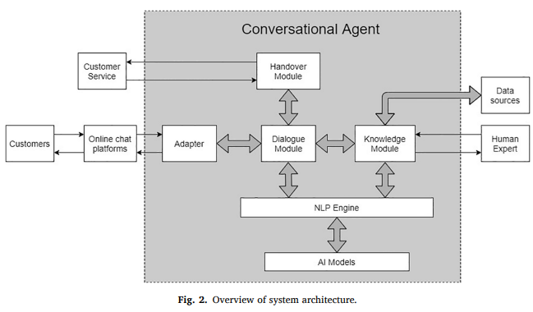

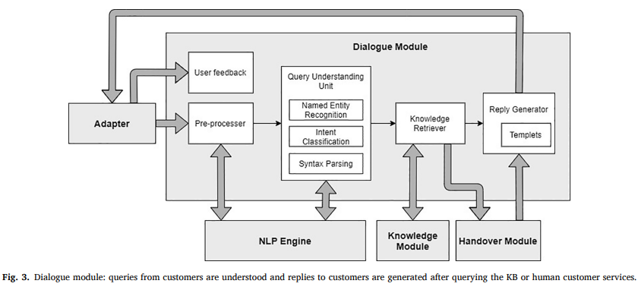

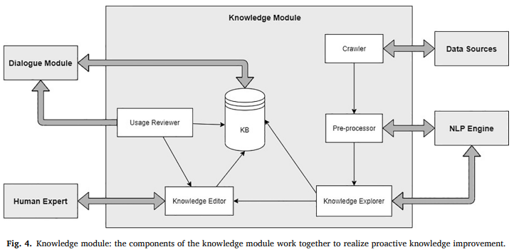

**6. OUTCOMES**

Here are a few expected outcomes:

* **Enhanced Customer Experience**: The chatbot will handle a large volume of queries efficiently, providing real-time responses, reducing waiting times, and improving customer satisfaction.
* **Increased Efficiency**: By automating common support requests, it will reduce the burden on human agents, allowing them to focus on complex issues.
* **Scalable Support**: The chatbot can scale to handle an increasing number of users simultaneously without the need for additional resources.
* **Continuous Learning**: The chatbot will adapt and improve over time through machine learning, enhancing its ability to provide accurate and relevant responses.
* **Improved Knowledge Base**: The chatbot will help build and update a dynamic knowledge base by learning from interactions and updating solutions for future use.
* **24/7 Availability**: The chatbot will offer uninterrupted customer service, available at any time to assist customers with their queries.
* **Personalized Responses**: Through NLP, the chatbot will deliver more personalized and contextual responses, improving customer satisfaction.
* **Data-Driven Insights**: The system will generate data from user interactions, helping the organization analyze trends and improve service quality.
* **Cost Reduction**: By automating support tasks, companies can reduce operational costs associated with human customer service agents.

**7. TIMELINE OF THE PROJECT/ PROJECT EXECUTION PLAN**

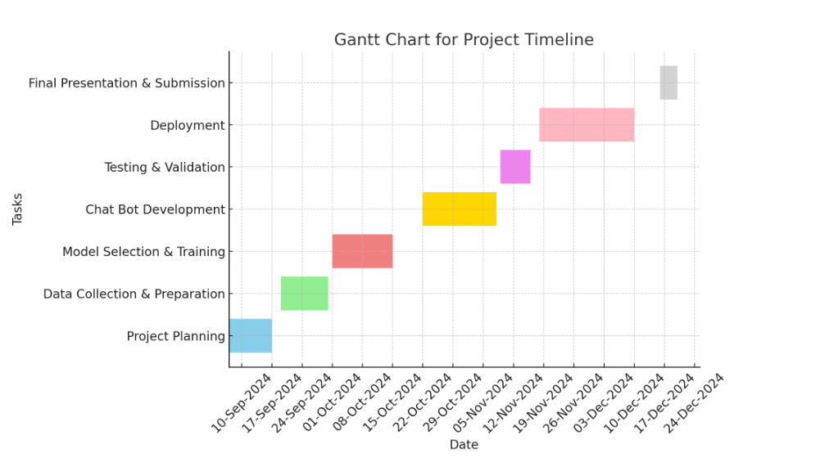

**8. CONCLUSION**

In conclusion, our machine learning (ML) powered chatbot for customer service is an entirely new way to improve customer relationships. To address the research gap identified in the literature, we proposed a KB design covering the customer knowledge required to manage customer relationship value cocreation and a system design that the KB will proactively improve. We evaluated the effectiveness of the designs through a case study of a leading international women’s intimate apparel manufacturer. Based on the user and expert evaluations, the results of the system prototype evaluation are satisfactory and support the contention that the system is effective. In our evaluation, we found that response time to customers was significantly shorter when the chatbot was used compared with before the chatbot was used. Moreover, human effort can be reduced significantly, while the accuracy of the chatbot was maintained at 100% in the test comparing the chatbot with the human staff. Therefore, the results of the evaluation showed that the designs can effectively improve efficiency in handling customer queries and thus customer relationship management.

This research can be extended to several areas for future work. First, additional case studies or tests can be conducted in different industries or companies for a holistic examination of the effectiveness of the design in terms of incorporating rich knowledge representation, machine learning, and retrieval techniques. Second, text-to-voice technology can be incorporated in the system to investigate response generation system designs for voice-based conversational agents, particularly in Chinese, owing to limited research in this context. Finally, a legacy system may be integrated in the conversational agent, such as an inventory system, to obtain knowledge on warehouse stocks and stock locations. This integration can provide the system with a competitive edge and capability to plan effectively, execute omnichannel strategies with customers predictably, and minimize labor costs and errors associated with manual reconciliation.

The current work briefly discussed topics related to text-based chatbots in the financial sector, such as the understanding of chatbots, their implementation, their adoption intention, attitude toward use, acceptance, trust, engagement and security and privacy vulnerabilities, based on existing literature. In the future, the described topics related to text-based chatbots can be studied empirically in detail to determine the extent to which they influence the implementation and development of chatbots in the financial sector.

**9. REFERENCES**

1. Prof.K. Bala, Mukesh Kumar, Sayali Hulawale and SahiI Pandita, "Chat-Bot For College Management System Using A.I", *International Research Journal of Engineering and Technology (IRJET)*, vol. 04, no. 11, pp. 2030-2033, Nov 2017.
2. Guruswami Hiremath, Aishwarya Hajare, Priyanka Bhosale, Rasika Nanaware and K. S. Wagh, "Chatbot for education system", *International Journal of Advance Research Ideas and Innovations in Technology (IJARIIT)*, vol. 4, no. 3, pp. 37-43, 2018.
3. K. Jwala, G.N.V.G Sirisha and G.V. Padma Raju, "Developing a Chatbot using Machine Learning", *International Journal of Recent Technology and Engineering (IJRTE)*, vol. 8, no. 1S3, pp. 89-92, June 2019.
4. Naeun Lee, Kirak Kim and Taeseon Yoon, "Implementation of Robot Journalism by Programming Custombot using Tokenization and Custom Tagging", *International Conference on Advanced Communications Technology (ICACT)*, pp. 566-570, Feb 2017.
5. Setiaji Bayu and Wibowo Ferry, "Chatbot Using a Knowledge in Database: Human-to-Machine Conversation Modeling", *7th International Conference on Intelligent Systems Modelling and Simulation (ISMS)*, pp. 72-77, Jan 2016.
6. M. Nuruzzaman and O. K. Hussain, "A survey on chatbot implementation in customer service industry through deep neural networks", *2018 IEEE 15th International Conference on e-Business Engineering (ICEBE).*, pp. 54-61, 2018.
7. A. Rahman, A. Al Mamun and A. Islam, "Programming challenges of chatbot: Current and future prospective", *2017 IEEE Region 10 Humanitarian Technology Conference (R10-HTC).*, pp. 75-78, 2017.
8. J. Hill, W. Ford and I. Farreras, *Real conversations with artificial intelligence: A comparison between human-human online conversations and human-chatbot conversations*, vol. 49, 2015.
9. I. Sutskever, Oriol Vinyals and Quoc V. Le, "Sequence to sequence learning with neural networks", *Advances in Neural Information Processing Systems 27:Annual Conference on Neural Information Processing Systems 2014*, pp. 3104-3112, December 8-13 2014.
10. M. Adam, M. Wessel, A. Benlian, Ai-based chatbots in customer service and their effects on user compliance, Electron. Mark. (2020), pp. 1-19